**Ateneo de Manila University**

**Department of Information Systems and Computer Science**

**Certificate of Authorship**

**Instructions**

* Accomplish this document completely.
* Each course requirement submission, unless otherwise specified by the Course Instructor, whether in electronic or paper form, must be accompanied by a corresponding properly accomplished Certificate of Authorship.

# Description of Submission

**Title of Submission:**  PracSys – Final Project

**Type of Submission:**  Program $√$ Project  Report  Paper  Other **Date of Submission:** October 17, 2014

# Certification

**We hereby certify that the submission described in this document abides by the principles stipulated in the DISCS Academic Integrity Policy document.**

**We further certify that we are the authors of this submission and that any assistance we received in its preparation is fully acknowledged and disclosed in the documentation.**

**We have also cited all sources from which we obtained data, ideas, or words that are directly copied or paraphrased in this document. Sources are properly credited according to accepted standards for professional publication.**

# Sources

Refer to the DISCS Citation Document for more information on how to properly cite sources. If this document is to be submitted in printed form and the citations exceed the space provided, please attach additional sheets to completely cite sources.

|  |
| --- |
|  |

# Group Information

# Full Name Signature

|  |  |
| --- | --- |
| **Ang, Hadrian Jules Y.** |  |
| **Mendoza, Melvin Luis D.** |  |
| **Palma, Miguel Jesus I.** |  |
| **See, Kyle Stephen S.** |  |
| **Ugalino, John Joseph R.** |  |

# Course Information

# Course Code & Section: CS123 – A

# Course Title: Introduction to Software Engineering

**Course Instructor:** Mr. Happy Alampay

**Statement of Work**

Project Name: Practicum Information System

Project Manager: Melvin Mendoza

Customer: Ma’am Jessica Sugay

Staff Estimates:

Name: Melvin Mendoza

Position: Project Manager

Man-hours per day: 3

Resume: ADMU Student Assistant (2014), CompSAT Tambay Week 2 Project Head (2013), DISCS App 2013 Project Head, ADMU Scholar, CompSAT General Assembly 1 (2013) Logistics

Name: Kyle See

Position: Senior Developer

Man-hours per day: 3

Resume: ACM-ICPC Philippines Multi-Provincial Programming Contest 2013 First Place, UP Java Cup 2013 First Place, UP Java Cup 2014 First Place, Ateneo Director’s List 2012

Name: Miguel Palma

Position: Senior Analyst

Man-hours per day: 3

Resume: Ateneo Programming Varsity 2012-2014, DOST Merit Scholar

Name: Hadrian Ang

Position: Junior Developer

Man-hours per day: 3

Resume: Ateneo Programming Varsity 2012-2014, Ateneo Director’s List 2012

Name: John Joseph Ugalino

Position: Junior Analyst

Man-hours per day: 3

Resume: Tagisang Robotics (2012), Ateneo Programming Varsity 2012

**Data Flow Diagrams**

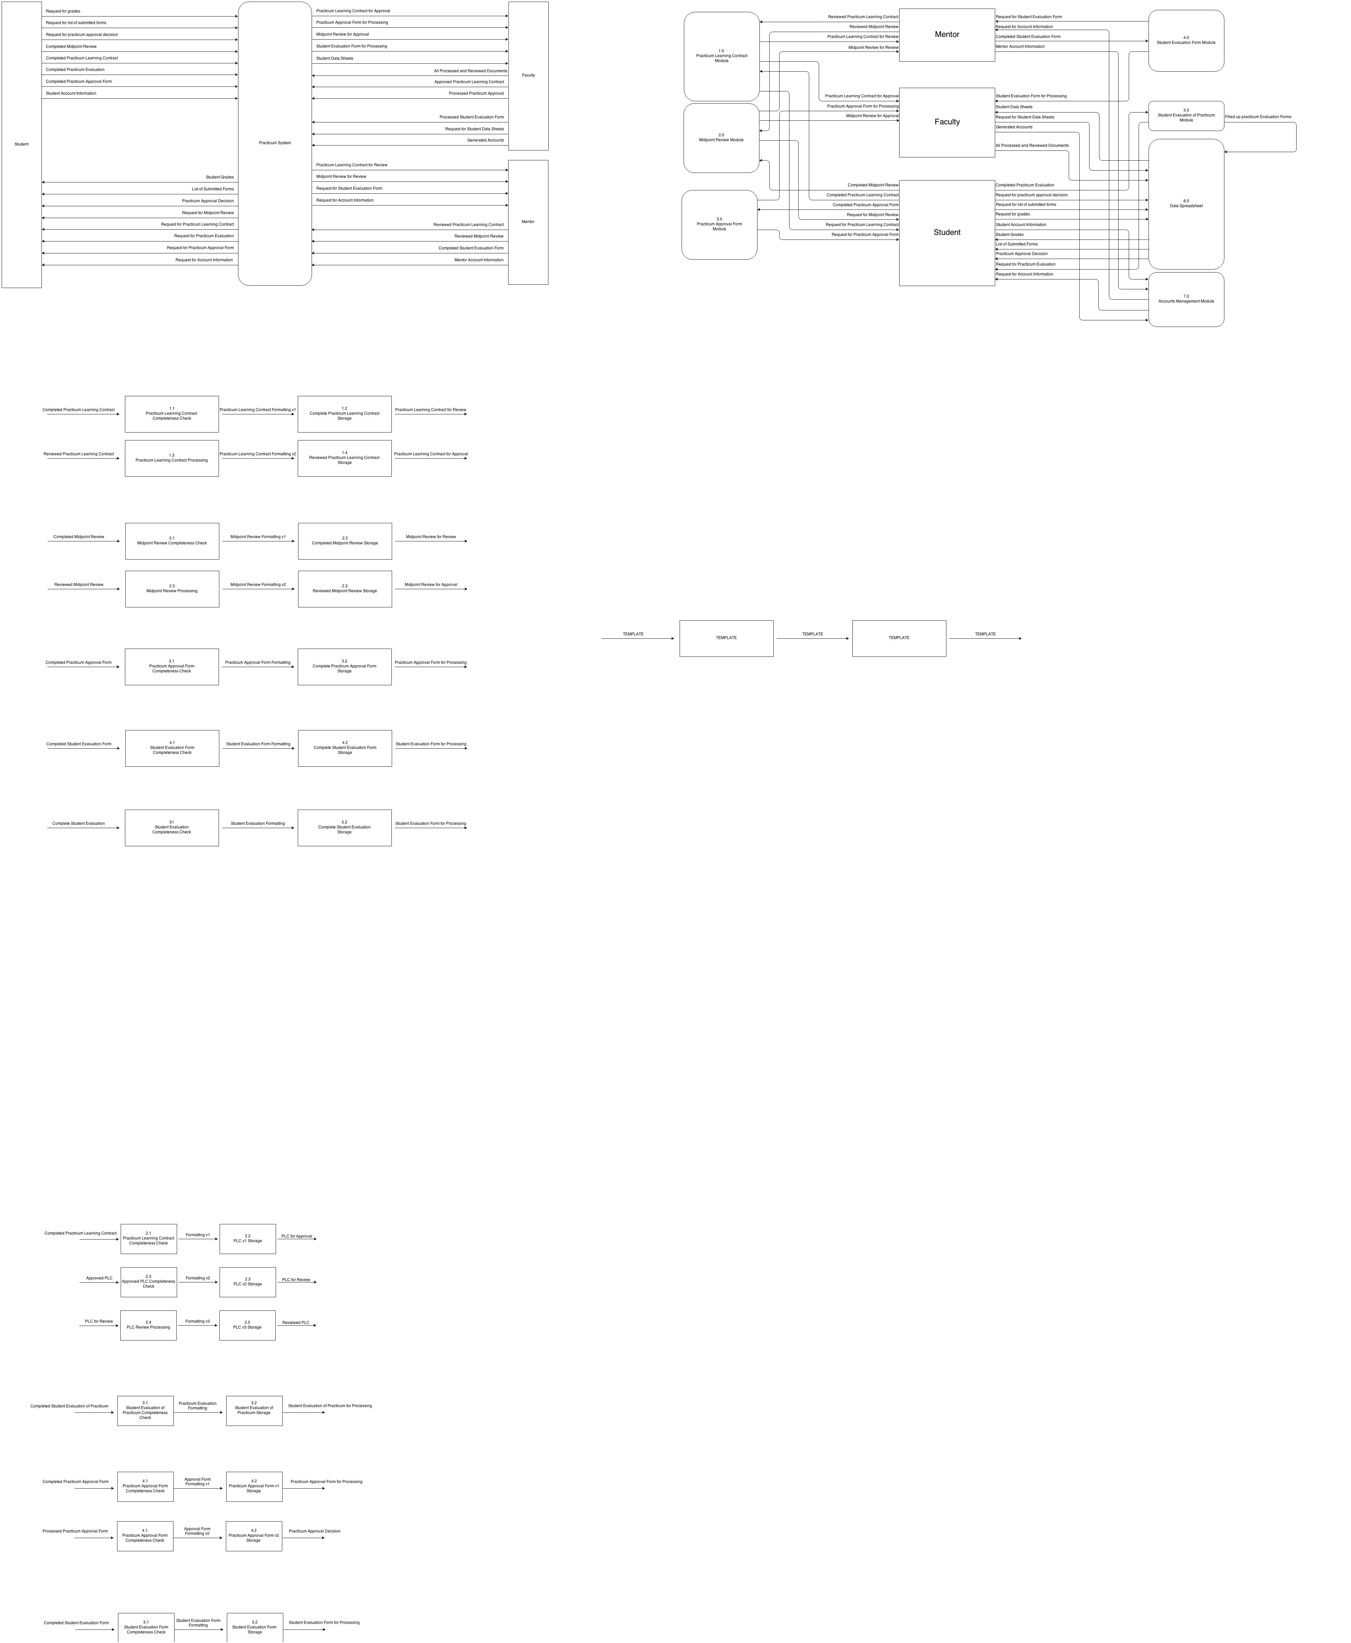**Level 0**

**Data Flow Diagrams**

**Level 1**

**Data Flow Diagrams**

**Level 2**

**Entity Relationship Diagram**

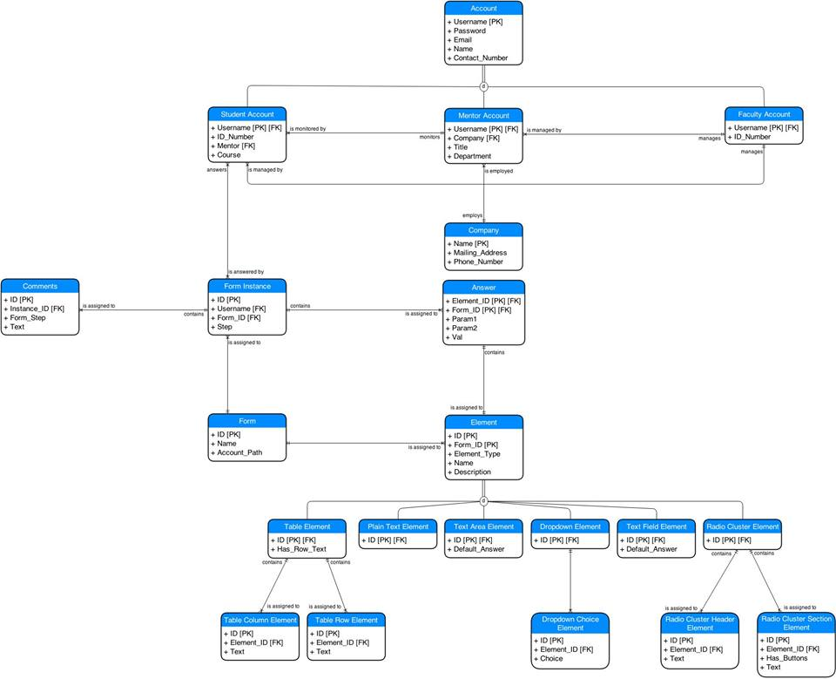

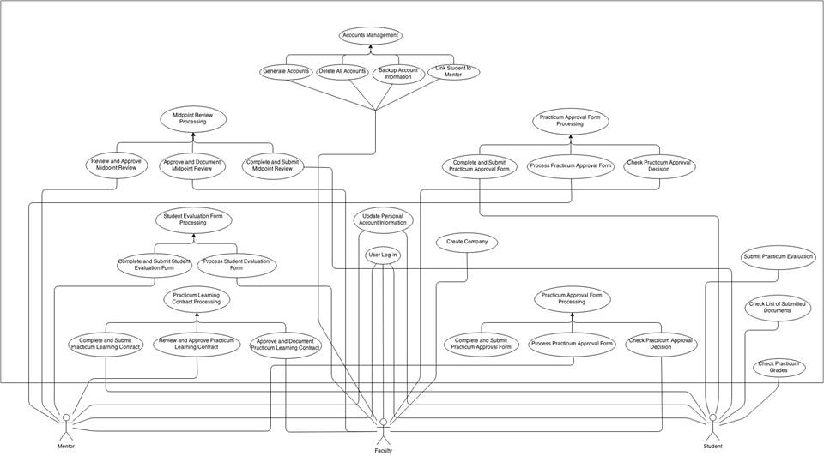**Use Case Diagram**

**Use Case Documentation**

Project Name: DISCS Practicum System

Project ID: 1.000

Executive Sponsor: Ma’am Jess

Project Manager: Melvin Luis Mendoza

Business Analyst: Miguel Palma

Date: October 17, 2014

Revision History

| **Version** | **Date** | **Revision Description** |
| --- | --- | --- |
| 0.1.0 | 8/11/14 | Proposed Use Cases |
| 0.1.1 | 10/3/14 | Added new Use Case |

# Approvals

We have carefully assessed the Use Cases for this project. This document has been completed in accordance with the requirements of the System Development Methodology.

MANAGEMENT CERTIFICATION - Please check the appropriate statement.

______ the document is accepted.

______ the document is accepted pending the changes noted.

______ the document is not accepted.

We fully accept the changes as needed improvements and authorize initiation of work to proceed. Based on our authority and judgment, the continued operation of this system is authorized.

(*=Required **= Submit for Review Approval Not Required)

Executive Sponsor** DATE

Project Sponsor* DATE

Quality Assurance Manager / Team Lead* DATE

Business Analyst Manager / Team Lead* DATE

Project Manager DATE

# Use Case List

|  |  |  |
| --- | --- | --- |
| **Use Case ID** | **Primary Actor** | **Use Cases** |
| 1.0-1.1 | Student, Faculty, Mentor, System | User Log-in |
| 2.0 | Student, Mentor | Update Information |
| 3.1-3.3 | Student, Mentor, Faculty | Midpoint Review Processing |
| 4.1-4.3 | Student, Faculty, Mentor | Practicum Learning Contract Processing |
| 5.1-5.3 | Student, Faculty | Practicum Approval Form Processing |
| 6.0 | Student | Student Evaluation of Practicum Processing |
| 7.1-7.2 | Mentor, Faculty | Student Evaluation Processing |
| 8.1-8.3 | Faculty | Accounts Management |
| 9.0 | Student | View Grades |
| 10.0 | Student | View List of Submitted Documents |
| 11.0 | Faculty | Create Company |

# User Log-in

|  |  |  |  |  |
| --- | --- | --- | --- | --- |
| **Use Case ID:** | 1.0 | | | |
| **Use Case Name:** | Log-in | | | |
| **Created By:** | Hadrian Ang | | **Last Updated By:** | Hadrian Ang |
| **Date Created:** | August 10, 2014 | | **Last Revision Date:** | August 10, 2014 |
| **Actors:** | | Student, Faculty, Moderator | | |
| **Description:** | | User inputs a username and password then clicks "Log-in" to log-in to the system | | |
| **Trigger:** | | Log-in button is clicked | | |
| **Preconditions:** | | 1. User is on the log-in page 2. User has an internet connection | | |
| **Postconditions:** | | 1. User is logged-in to account 2. Error message is displayed and user must attempt to log-in again | | |
| **Normal Flow:** | | 1. User inputs username 2. User inputs password 3. User clicks log-in button 4. User is logged-in | | |
| **Alternative Flows:**  **[Alternative Flow 1 – Incorrect Credentials]** | | 4.1. In step 4 of the normal flow, if log-in credentials are incorrect   1. Error message regarding credentials is displayed 2. User clicks "OK" 3. Use Case resumes on step 1 | | |
| **Exceptions:** | | 3.1. Internal Server Error (HTTP Code 500)   1. System will log exception and any messages related 2. System will return error page to User | | |
| **Includes:** | | Log-in Credential Verification | | |
| **Frequency of Use:** | | Anytime a user needs to use the system (most likely daily during practicum season) | | |
| **Special Requirements:** | | Must guard against exploits that may lead to unauthorized access | | |
| **Assumptions:** | | N/A | | |
| **Notes and Issues:** | | N/A | | |

# Update Information

|  |  |  |  |  |
| --- | --- | --- | --- | --- |
| **Use Case ID:** | 2.0 | | | |
| **Use Case Name:** | Update Information | | | |
| **Created By:** | Hadrian Ang | | **Last Updated By:** | Hadrian Ang |
| **Date Created:** | August 10, 2014 | | **Last Revision Date:** | August 10, 2014 |
| **Actors:** | | Student, Mentor | | |
| **Description:** | | Allows a user to edit account information such as their passwords | | |
| **Trigger:** | | User clicks “Update Information” button | | |
| **Preconditions:** | | 1. User is logged-in | | |
| **Postconditions:** | | 1. User’s information is updated 2. Error message is displayed for invalid information | | |
| **Normal Flow:** | | 1. User clicks “Update Information” 2. User is asked to input current password 3. User may now edit any of the available information fields 4. User’s information is now updated 5. User is returned to main page | | |
| **Alternative Flows:**  **[Incorrect Password]** | | 2.1. Password that was input is incorrect   1. Wrong password error message is displayed 2. Use case returns to step 2 | | |
| **Alternative Flows:**  **[Invalid Field]** | | 4.1. An invalid value has been input into one of the fields   1. Error message of invalid value is displayed 2. Fields with errors are marked 3. Use Case returns to step 3 | | |
| **Exceptions:** | | 3.1 Internal Server Error (HTTP Code 500)   1. System will log exception and any messages related 2. System will return error page to User | | |
| **Includes:** | | 1.1 Verify Credentials | | |
| **Frequency of Use:** | | Seldom (though all users are highly encouraged to updated pre-generated passwords created by Faculty) | | |
| **Special Requirements:** | | N/A | | |
| **Assumptions:** | | User must be logged-in in order to update information | | |
| **Notes and Issues:** | | N/A | | |

# Midpoint Review Processing

|  |  |  |  |  |
| --- | --- | --- | --- | --- |
| **Use Case ID:** | 3.1 | | | |
| **Use Case Name:** | Complete and Submit Midpoint Review | | | |
| **Created By:** | Hadrian Ang | | **Last Updated By:** | Hadrian Ang |
| **Date Created:** | August 10, 2014 | | **Last Revision Date:** | August 10, 2014 |
| **Actors:** | | Student | | |
| **Description:** | | Allows student to complete and submit a midpoint review form | | |
| **Trigger:** | | Student clicks “Submit Midpoint Review” button | | |
| **Preconditions:** | | 1. It is time for the midpoint review 2. User is logged on as a student | | |
| **Postconditions:** | | 1. Midpoint review is submitted 2. Invalid field error message is displayed | | |
| **Normal Flow:** | | 1. Student clicks “Submit Midpoint Review” 2. Fills up form with necessary information 3. Student clicks “Submit” button 4. Completed Midpoint Review is sent to the system | | |
| **Alternative Flows:**  **[Incomplete or Invalid Fields]** | | 2.1. Some of the fields in the Midpoint Review form are incomplete or invalid   1. Error message is displayed 2. Incomplete or invalid fields are marked 3. Use case returns to step 2 | | |
| **Exceptions:** | | 3.1 Internal Server Error (HTTP Code 500)   1. System will log exception and any messages related 2. System will return error page to User | | |
| **Includes:** | | N/A | | |
| **Frequency of Use:** | | Once per student or when form is sent back | | |
| **Special Requirements:** | | N/A | | |
| **Assumptions:** | | User must be logged-in as a student to accomplish the midterm review | | |
| **Notes and Issues:** | | N/A | | |

|  |  |  |  |  |
| --- | --- | --- | --- | --- |
| **Use Case ID:** | 3.2 | | | |
| **Use Case Name:** | Review and Approve Midpoint Review | | | |
| **Created By:** | Hadrian Ang | | **Last Updated By:** | Hadrian Ang |
| **Date Created:** | August 10, 2014 | | **Last Revision Date:** | August 10, 2014 |
| **Actors:** | | Mentor | | |
| **Description:** | | Allows mentors to review Midpoint reviews submitted by the students under them | | |
| **Trigger:** | | Mentor clicks “Review Midpoint Reviews” button | | |
| **Preconditions:** | | 1. It is time for the midpoint review 2. User is logged on as a Mentor | | |
| **Postconditions:** | | 1. Student’s midpoint review is approved 2. Student’s midpoint review is sent back with comments | | |
| **Normal Flow:** | | 1. Mentor clicks “Review Midpoint Reviews” 2. Table of students is displayed together with status of their midpoint review (submitted or not) 3. Mentor clicks on a student who has submitted a review 4. Student’s midpoint review form is displayed 5. Mentor approves midpoint review 6. Midpoint review is sent back into system reviewed | | |
| **Alternative Flows:**  **[Midpoint Review is not approved]** | | 5.1. Mentor has questions or comments about student’s midpoint review   1. Mentor inputs comments or questions 2. Midpoint review is sent back to student 3. Use case returns to step 2 | | |
| **Exceptions:** | | 5.1 Internal Server Error (HTTP Code 500)   1. System will log exception and any messages related 2. System will return error page to User | | |
| **Includes:** | | N/A | | |
| **Frequency of Use:** | | Whenever completed midpoint review is received | | |
| **Special Requirements:** | | N/A | | |
| **Assumptions:** | | 1. User must be logged-in as a mentor to review midpoint reviews. 2. Mentors have students under them. | | |
| **Notes and Issues:** | | N/A | | |

|  |  |  |  |  |
| --- | --- | --- | --- | --- |
| **Use Case ID:** | 3.3 | | | |
| **Use Case Name:** | Approve and Document Midpoint Review | | | |
| **Created By:** | Hadrian Ang | | **Last Updated By:** | Hadrian Ang |
| **Date Created:** | August 10, 2014 | | **Last Revision Date:** | August 10, 2014 |
| **Actors:** | | Faculty | | |
| **Description:** | | Allows Faculty to approve midpoint reviews and upload necessary data to the document inventor for student grade computation | | |
| **Trigger:** | | Faculty clicks “Approve Midpoint Reviews” button | | |
| **Preconditions:** | | 1. It is time for the midpoint review 2. User is logged on as Faculty | | |
| **Postconditions:** | | 1. Student’s midpoint review is approved and documented for grading 2. Student’s midpoint review is sent back with comments | | |
| **Normal Flow:** | | 1. Faculty clicks “Approve Midpoint Reviews” 2. Table of students is displayed together with status of their midpoint review (submitted, for mentor approval, or not yet submitted) 3. Faculty clicks on a student who has submitted a review that has already been approved by the student’s mentor 4. Student’s midpoint review form is displayed 5. Faculty approves midpoint review 6. Midpoint review is sent into the system and documented for grading | | |
| **Alternative Flows:**  **[Midpoint Review is not approved]** | | 6.1. Mentor has questions or comments about student’s midpoint review   1. Faculty inputs comments or questions 2. Midpoint review is sent back to student 3. Use case returns to step 2 | | |
| **Exceptions:** | | 5.1 Internal Server Error (HTTP Code 500)   1. System will log exception and any messages related 2. System will return error page to User | | |
| **Includes:** | | N/A | | |
| **Frequency of Use:** | | Whenever reviewed midpoint review is received | | |
| **Special Requirements:** | | N/A | | |
| **Assumptions:** | | User must be logged-in as faculty to Approve Midpoint Review | | |
| **Notes and Issues:** | | N/A | | |

# Practicum Learning Contract Processing

|  |  |  |  |  |
| --- | --- | --- | --- | --- |
| **Use Case ID:** | 4.1 | | | |
| **Use Case Name:** | Complete and Submit Practicum Learning Contract | | | |
| **Created By:** | Hadrian Ang | | **Last Updated By:** | Hadrian Ang |
| **Date Created:** | August 11, 2014 | | **Last Revision Date:** | August 11, 2014 |
| **Actors:** | | Student | | |
| **Description:** | | Allows student to complete and submit a Practicum Learning Contract | | |
| **Trigger:** | | Student clicks “Submit Practicum Learning Contract” button | | |
| **Preconditions:** | | 1. User is logged on as a student | | |
| **Postconditions:** | | 1. Practicum Learning Contract is submitted 2. Invalid field error message is displayed | | |
| **Normal Flow:** | | 1. Student clicks “Submit Practicum Learning Contract” 2. Fills up form with necessary information 3. Student clicks “Submit” button 4. Filled out Practicum Learning Contract is sent to the system for reviewing by the Mentor | | |
| **Alternative Flows:**  **[Incomplete or Invalid Fields]** | | 2.1. Some of the fields in the Practicum Learning Contract form are incomplete or invalid   1. Error message is displayed 2. Incomplete or invalid fields are marked 3. Use case returns to step 2 | | |
| **Exceptions:** | | 4.1 Internal Server Error (HTTP Code 500)   1. System will log exception and any messages related 2. System will return error page to User | | |
| **Includes:** | | N/A | | |
| **Frequency of Use:** | | Once per student or when form is sent back | | |
| **Special Requirements:** | | N/A | | |
| **Assumptions:** | | User must be logged-in as a student to accomplish the Practicum Learning Contract | | |
| **Notes and Issues:** | | N/A | | |

|  |  |  |  |  |
| --- | --- | --- | --- | --- |
| **Use Case ID:** | 4.2 | | | |
| **Use Case Name:** | Review and Approve Practicum Learning Contract | | | |
| **Created By:** | Hadrian Ang | | **Last Updated By:** | Hadrian Ang |
| **Date Created:** | August 11, 2014 | | **Last Revision Date:** | August 11, 2014 |
| **Actors:** | | Mentor | | |
| **Description:** | | Allows mentors to review Practicum Learning Contracts submitted by the students under them | | |
| **Trigger:** | | Mentor clicks “Review Practicum Learning Contracts” button | | |
| **Preconditions:** | | 1. User is logged on as a Mentor | | |
| **Postconditions:** | | 1. Student’s Practicum Learning Contract is approved 2. Student’s Practicum Learning Contract is sent back with comments | | |
| **Normal Flow:** | | 1. Mentor clicks “Review Practicum Learning Contracts” 2. Table of students is displayed together with status of their Practicum Learning Contract (submitted or not) 3. Mentor clicks on a student who has submitted a Practicum Learning Contract 4. Student’s Practicum Learning Contract form is displayed 5. Mentor approves Practicum Learning Contract 6. Practicum Learning Contract is sent back into system reviewed and ready for Faculty checking | | |
| **Alternative Flows:**  **[Practicum Learning Contract is not approved]** | | 5.1. Mentor has questions or comments about student’s Practicum Learning Contract   1. Mentor inputs comments or questions 2. Practicum Learning Contract is sent back to student 3. Use case returns to step 2 | | |
| **Exceptions:** | | 6.1 Internal Server Error (HTTP Code 500)   1. System will log exception and any messages related 2. System will return error page to User | | |
| **Includes:** | | N/A | | |
| **Frequency of Use:** | | Whenever completed Practicum Learning Contract is received | | |
| **Special Requirements:** | | N/A | | |
| **Assumptions:** | | 1. User must be logged-in as a mentor to review practicum learning contract 2. Mentors have students under them. | | |
| **Notes and Issues:** | | N/A | | |

|  |  |  |  |  |
| --- | --- | --- | --- | --- |
| **Use Case ID:** | 4.3 | | | |
| **Use Case Name:** | Approve and Document Practicum Learning Contract | | | |
| **Created By:** | Hadrian Ang | | **Last Updated By:** | Hadrian Ang |
| **Date Created:** | August 11, 2014 | | **Last Revision Date:** | August 11, 2014 |
| **Actors:** | | Faculty | | |
| **Description:** | | Allows Faculty to approve Practicum Learning Contracts that were reviewed by mentors and put them back into the system for grade computation | | |
| **Trigger:** | | Faculty clicks “Approve Practicum Learning Contracts” button | | |
| **Preconditions:** | | 1. User is logged on as Faculty | | |
| **Postconditions:** | | 1. Student’s Practicum Learning Contract is approved 2. Student’s Practicum Learning Contract is sent back with comments | | |
| **Normal Flow:** | | 1. Faculty clicks “Approve Practicum Learning Contracts” 2. Table of students is displayed together with status of their Practicum Learning Contract (submitted, with mentor or not submitted) 3. Faculty clicks on a student who has submitted a Practicum Learning Contract 4. Student’s Practicum Learning Contract form is displayed 5. Faculty approves Practicum Learning Contract 6. Practicum Learning Contract is sent back into system reviewed and ready for Faculty checking | | |
| **Alternative Flows:**  **[Practicum Learning Contract is not approved]** | | 5.1. Faculty has questions or comments about student’s Practicum Learning Contract   1. Faculty inputs comments or questions 2. Practicum Learning Contract is sent back to student 3. Use case returns to step 2 | | |
| **Exceptions:** | | 6.1 Internal Server Error (HTTP Code 500)   1. System will log exception and any messages related 2. System will return error page to User | | |
| **Includes:** | | N/A | | |
| **Frequency of Use:** | | Whenever completed Practicum Learning Contract is received | | |
| **Special Requirements:** | | N/A | | |
| **Assumptions:** | | User must be logged-in as a Faculty to approve Practicum Learning Contracts that have been reviewed by mentors | | |
| **Notes and Issues:** | | N/A | | |

# Practicum Approval Form Processing

|  |  |  |  |  |
| --- | --- | --- | --- | --- |
| **Use Case ID:** | 5.1 | | | |
| **Use Case Name:** | Complete and Submit Practicum Approval Form | | | |
| **Created By:** | Hadrian Ang | | **Last Updated By:** | Hadrian Ang |
| **Date Created:** | August 11, 2014 | | **Last Revision Date:** | August 11, 2014 |
| **Actors:** | | Student | | |
| **Description:** | | Allows student to complete and submit a Practicum Approval Form | | |
| **Trigger:** | | Student clicks “Submit Practicum Approval Form” | | |
| **Preconditions:** | | 1. User is logged on as a student | | |
| **Postconditions:** | | 1. Practicum Approval Form is submitted 2. Invalid field error message is displayed | | |
| **Normal Flow:** | | 1. Student clicks “Submit Practicum Approval Form” button 2. Fills up form with necessary information 3. Student clicks “Submit” button 4. Filled out Practicum Approval Form is sent to the system for approval by the Faculty | | |
| **Alternative Flows:**  **[Incomplete or Invalid Fields]** | | 2.1. Some of the fields in the Practicum Approval Form are incomplete or invalid   1. Error message is displayed 2. Incomplete or invalid fields are marked 3. Use case returns to step 2 | | |
| **Exceptions:** | | 4.1 Internal Server Error (HTTP Code 500)   1. System will log exception and any messages related 2. System will return error page to User | | |
| **Includes:** | | N/A | | |
| **Frequency of Use:** | | Once per student or when form is sent back | | |
| **Special Requirements:** | | N/A | | |
| **Assumptions:** | | User must be logged-in as a student to accomplish the Practicum Approval Form | | |
| **Notes and Issues:** | | N/A | | |

|  |  |  |  |  |
| --- | --- | --- | --- | --- |
| **Use Case ID:** | 5.2 | | | |
| **Use Case Name:** | Process Practicum Approval Form | | | |
| **Created By:** | Hadrian Ang | | **Last Updated By:** | Hadrian Ang |
| **Date Created:** | August 11, 2014 | | **Last Revision Date:** | August 11, 2014 |
| **Actors:** | | Faculty | | |
| **Description:** | | Allows Faculty to check or process Practicum Approval Forms and send decisions to students | | |
| **Trigger:** | | Faculty clicks “Process Practicum Approval Form” button | | |
| **Preconditions:** | | 1. User is logged on as Faculty | | |
| **Postconditions:** | | 1. Student’s Practicum Approval Form is approved and decision is sent to the student 2. Student’s Practicum Learning Contract is sent back with comments | | |
| **Normal Flow:** | | 1. Faculty clicks “Process Practicum Approval Forms” 2. Table of students is displayed together with status of their Practicum Approval Forms (submitted or not submitted) 3. Faculty clicks on a student who has submitted a Practicum Approval Form 4. Student’s Practical Approval Form is displayed 5. Faculty approves Practicum Approval Form 6. Practicum Approval Form is sent back into system reviewed and ready for Faculty checking | | |
| **Alternative Flows:**  **[Practicum Approval Form is not approved]** | | 6.1. Faculty has questions or comments about student’s Practicum Approval Form   1. Faculty inputs comments or questions 2. Practicum Approval Form is sent back to student 3. Use case returns to step 2 | | |
| **Exceptions:** | | 6.1 Internal Server Error (HTTP Code 500)   1. System will log exception and any messages related 2. System will return error page to User | | |
| **Includes:** | | N/A | | |
| **Frequency of Use:** | | Whenever completed Practicum Approval Form is received | | |
| **Special Requirements:** | | N/A | | |
| **Assumptions:** | | User must be logged-in as a Faculty to check Practicum Approval Forms | | |
| **Notes and Issues:** | | N/A | | |

|  |  |  |  |  |
| --- | --- | --- | --- | --- |
| **Use Case ID:** | 5.3 | | | |
| **Use Case Name:** | Check Practicum Approval Decision | | | |
| **Created By:** | Hadrian Ang | | **Last Updated By:** | Hadrian Ang |
| **Date Created:** | August 11, 2014 | | **Last Revision Date:** | August 11, 2014 |
| **Actors:** | | Student | | |
| **Description:** | | Allows student to check whether or not his Practicum was approved or not | | |
| **Trigger:** | | Student clicks “Check Practicum Approval Decision” | | |
| **Preconditions:** | | 1. User is logged on as a student 2. Student has already submitted a Practicum Approval Form | | |
| **Postconditions:** | | 1. Application is shown to be accepted 2. Rejected Application is shown with comments or questions 3. No decision has been made by faculty yet | | |
| **Normal Flow:** | | 1. Student clicks “Check Practicum Approval Decision” button 2. Approved Status is displayed on screen | | |
| **Alternative Flows:**  **[Practicum not Approved]** | | 2.1. The Practicum applied for has not been approved by faculty   1. Practicum Approval Form is displayed with comments and questions 2. Student may then accomplish the form again | | |
| **Alternative Flows:**  **[No Decision Yet]** | | 2.1 Faculty has yet to send a decision for the student’s Practicum Approval Form   1. Student is presented with option to refresh page or return to main page | | |
| **Exceptions:** | | 2.1 Internal Server Error (HTTP Code 500)   1. System will log exception and any messages related 2. System will return error page to User | | |
| **Includes:** | | N/A | | |
| **Frequency of Use:** | | Whenever student wants to check decision on Practicum Approval | | |
| **Special Requirements:** | | N/A | | |
| **Assumptions:** | | User must be logged-in as a student to check decision of Practicum Approval | | |
| **Notes and Issues:** | | N/A | | |

# Student Evaluation of Practicum Processing

|  |  |  |  |  |
| --- | --- | --- | --- | --- |
| **Use Case ID:** | 6.0 | | | |
| **Use Case Name:** | Submit Practicum Evaluation | | | |
| **Created By:** | Hadrian Ang | | **Last Updated By:** | Hadrian Ang |
| **Date Created:** | August 11, 2014 | | **Last Revision Date:** | August 11, 2014 |
| **Actors:** | | Student | | |
| **Description:** | | Allows student to complete and submit an Evaluation of Practicum Form | | |
| **Trigger:** | | Student clicks “Submit Evaluation of Practicum” | | |
| **Preconditions:** | | 1. User is logged on as a student 2. It is time to submit the Evaluation of Practicum Form | | |
| **Postconditions:** | | 1. Evaluation of Practicum is submitted 2. Invalid field error message is displayed | | |
| **Normal Flow:** | | 1. Student clicks “Submit Evaluation of Practicum” button 2. Student fills up form with necessary information 3. Student clicks “Submit” button 4. Filled out Practicum Evaluation Form is sent to the system and is documented for grading and faculty viewing | | |
| **Alternative Flows:**  **[Incomplete or Invalid Fields]** | | 2.1. Some of the fields in the Practicum Evaluation Form are incomplete or invalid   1. Error message is displayed 2. Incomplete or invalid fields are marked 3. Use case returns to step 2 | | |
| **Exceptions:** | | 4.1 Internal Server Error (HTTP Code 500)   1. System will log exception and any messages related 2. System will return error page to User | | |
| **Includes:** | | N/A | | |
| **Frequency of Use:** | | Once per student | | |
| **Special Requirements:** | | N/A | | |
| **Assumptions:** | | User must be logged-in as a student to accomplish Practicum Evaluation Form | | |
| **Notes and Issues:** | | N/A | | |

# Student Evaluation Form Processing

|  |  |  |  |  |
| --- | --- | --- | --- | --- |
| **Use Case ID:** | 7.1 | | | |
| **Use Case Name:** | Complete and Submit Student Evaluation Form | | | |
| **Created By:** | John Joseph Ugalino | | **Last Updated By:** | Hadrian Ang |
| **Date Created:** | August 11, 2014 | | **Last Revision Date:** | August 11, 2014 |
| **Actors:** | | Mentor | | |
| **Description:** | | Allows mentor to complete and submit an Student Evaluation Form | | |
| **Trigger:** | | Mentor clicks “Submit Student Evaluation” button | | |
| **Preconditions:** | | 1. User is logged on as Mentor 2. It is time to submit the Student Evaluation Form | | |
| **Postconditions:** | | 1. Student Evaluation Form is submitted 2. Invalid field error message is displayed | | |
| **Normal Flow:** | | 1. Mentor clicks “Submit Student Evaluation” button 2. Mentor fills up form with necessary information 3. Mentor clicks “Submit” button 4. Filled out Practicum Evaluation Form is sent to the system and is documented for faculty viewing | | |
| **Alternative Flows:**  **[Incomplete or Invalid Fields]** | | 2.1. Some of the fields in the Student Evaluation Form are incomplete or invalid   1. Error message is displayed 2. Incomplete or invalid fields are marked 3. Use case returns to step 2 | | |
| **Exceptions:** | | 4.1 Internal Server Error (HTTP Code 500)   1. System will log exception and any messages related 2. System will return error page to User | | |
| **Includes:** | | N/A | | |
| **Frequency of Use:** | | Once per student being mentored | | |
| **Special Requirements:** | | N/A | | |
| **Assumptions:** | | User must be logged-in as a mentor to accomplish Student Evaluation Form | | |
| **Notes and Issues:** | | N/A | | |

|  |  |  |  |  |
| --- | --- | --- | --- | --- |
| **Use Case ID:** | 7.2 | | | |
| **Use Case Name:** | Process Student Evaluation Form | | | |
| **Created By:** | John Joseph Ugalino | | **Last Updated By:** | Hadrian Ang |
| **Date Created:** | August 11, 2014 | | **Last Revision Date:** | August 11, 2014 |
| **Actors:** | | Faculty | | |
| **Description:** | | Allows mentor to complete and submit an Student Evaluation Form | | |
| **Trigger:** | | Mentor clicks “Submit Student Evaluation” button | | |
| **Preconditions:** | | 1. User is logged on as Faculty | | |
| **Postconditions:** | | 1. Student Evaluation Form is processed and documented into the system 2. Faculty sends form back to mentor with questions or comments | | |
| **Normal Flow:** | | 1. Faculty clicks “Process Student Evaluations” button 2. Names of all students are displayed together with status of their evaluation (submitted, not submitted) 3. Faculty clicks on a student’s name 4. Student’s evaluation is displayed 5. Faculty approves evaluation and it is sent for documentation | | |
| **Alternative Flows:**  **[Faculty has Comments on Evaluation]** | | 5.1. Faculty has questions or comments regarding student evaluation   1. Faculty inputs questions or comments 2. Form is sent back to mentor 3. Use case returns to step 2 | | |
| **Exceptions:** | | 5.1 Internal Server Error (HTTP Code 500)   1. System will log exception and any messages related 2. System will return error page to User | | |
| **Includes:** | | N/A | | |
| **Frequency of Use:** | | Once per student being mentored | | |
| **Special Requirements:** | | N/A | | |
| **Assumptions:** | | User must be logged-in as Faculty to process Evaluation Forms | | |
| **Notes and Issues:** | | N/A | | |

# Accounts Management

|  |  |  |  |  |
| --- | --- | --- | --- | --- |
| **Use Case ID:** | 8.1 | | | |
| **Use Case Name:** | Generate Accounts | | | |
| **Created By:** | Hadrian Ang | | **Last Updated By:** | Hadrian Ang |
| **Date Created:** | August 11, 2014 | | **Last Revision Date:** | August 11, 2014 |
| **Actors:** | | Faculty | | |
| **Description:** | | Allows Faculty to create student or mentor accounts | | |
| **Trigger:** | | Faculty clicks “Generate Accounts” button | | |
| **Preconditions:** | | 1. User is logged on as Faculty | | |
| **Postconditions:** | | 1. Accounts have been generated from file 2. Error reading from file 3. New Account has been generated | | |
| **Normal Flow:** | | 1. Faculty clicks of “Generate Accounts” button 2. Faculty clicks “Generate Accounts from file” 3. Faculty is prompted to upload a csv or Excel file 4. File is uploaded into the system 5. File is read by the system 6. Accounts are generated from information in the file | | |
| **Alternative Flows:**  **[Error Reading From File]** | | 5.1. Error reading from file (file may not be formatted correctly or is not the right file type)   1. Error reading from file message is displayed 2. User is returned to the file upload page 3. Use case returns to step 3 | | |
| **Alternative Flows:**  **[Faculty Generates Account Manually]** | | 2.1. Faculty clicks “Generate Account Manually” button   1. Faculty is prompted to input account information (type of account, name, optional password) 2. Faculty clicks “Create Account Button” 3. New Account is generated based on information | | |
| **Alternative Flows:**  **[Incomplete or Invalid Fields]** | | 2.1.2. Some of the fields that were input have invalid or incomplete values   1. Invalid or incomplete fields are marked 2. Use case resumes at step 2.1.1 | | |
| **Exceptions:** | | 6.1 Internal Server Error (HTTP Code 500)   1. System will log exception and any messages related 2. System will return error page to User | | |
| **Includes:** | | N/A | | |
| **Frequency of Use:** | | Whenever new accounts are needed | | |
| **Special Requirements:** | | N/A | | |
| **Assumptions:** | | Only Faculty may generate accounts | | |
| **Notes and Issues:** | | N/A | | |
| **Use Case ID:** | 8.2 | | | |
| **Use Case Name:** | Wipe Accounts | | | |
| **Created By:** | Hadrian Ang | | **Last Updated By:** | Hadrian Ang |
| **Date Created:** | August 11, 2014 | | **Last Revision Date:** | August 11, 2014 |
| **Actors:** | | Faculty | | |
| **Description:** | | Allows faculty to wipe database of accounts | | |
| **Trigger:** | | Faculty clicks “Wipe Accounts” button | | |
| **Preconditions:** | | 1. User is logged on as Faculty | | |
| **Postconditions:** | | 1. Chosen accounts have been wiped 2. Action has been cancelled | | |
| **Normal Flow:** | | 1. Faculty clicks “Wipe Accounts” button 2. Faculty selects to wipe all accounts or only student / mentor accounts 3. Faculty is prompted whether she is sure she wants to wipe selected account data 4. Faculty is asked whether to back-up the data or not (see use case 8.3) 5. Selected account data is wiped | | |
| **Alternative Flows:**  **[Action is Cancelled]** | | 3.1. Account wipe is cancelled   1. Faculty is sent back to main page | | |
| **Exceptions:** | | 4.1 Internal Server Error (HTTP Code 500)   1. System will log exception and any messages related 2. System will return error page to User | | |
| **Includes:** | | N/A | | |
| **Frequency of Use:** | | Whenever an account wipe is needed | | |
| **Special Requirements:** | | N/A | | |
| **Assumptions:** | | Only Faculty may wipe accounts | | |
| **Notes and Issues:** | | N/A | | |

|  |  |  |  |  |
| --- | --- | --- | --- | --- |
| **Use Case ID:** | 8.3 | | | |
| **Use Case Name:** | Back-up Account Information | | | |
| **Created By:** | Hadrian Ang | | **Last Updated By:** | Hadrian Ang |
| **Date Created:** | August 11, 2014 | | **Last Revision Date:** | August 11, 2014 |
| **Actors:** | | Faculty | | |
| **Description:** | | Allows faculty to download a csv file containing all account information | | |
| **Trigger:** | | Faculty clicks “Back-up Accounts” button or clicks yes when prompted during Account Wipe (see use case 8.2) | | |
| **Preconditions:** | | 1. User is logged on as Faculty | | |
| **Postconditions:** | | 1. Selected account data is downloaded as a csv file | | |
| **Normal Flow:** | | 1. Faculty clicks “Back-up Accounts” button 2. System generates a csv file from the database 3. Csv file is downloaded into the user’s computer | | |
| **Exceptions:** | | 3.1 Internal Server Error (HTTP Code 500)   1. System will log exception and any messages related 2. System will return error page to User | | |
| **Extends** | | 8.2 Wipe Accounts | | |
| **Frequency of Use:** | | Whenever an account wipe is needed | | |
| **Special Requirements:** | | N/A | | |
| **Assumptions:** | | Only Faculty may back-up account information | | |
| **Notes and Issues:** | | N/A | | |

|  |  |  |  |  |
| --- | --- | --- | --- | --- |
| **Use Case ID:** | 8.4 | | | |
| **Use Case Name:** | Link Student to Mentor | | | |
| **Created By:** | Melvin Luis Mendoza | | **Last Updated By:** | Melvin Luis Mendoza |
| **Date Created:** | October 4, 2014 | | **Last Revision Date:** | October 4, 2014 |
| **Actors:** | | Faculty | | |
| **Description:** | | Allows faculty to assign or remove student accounts to their respective mentors and vice versa | | |
| **Trigger:** | | Faculty clicks “Manage accounts” button | | |
| **Preconditions:** | | 1. User is logged on as Faculty | | |
| **Postconditions:** | | 1. A student account is linked to its respective mentor account and vice versa 2. A student account is delinked from its respective mentor account and vice versa | | |
| **Normal Flow:** | | 1. Faculty clicks “Manage accounts” button 2. System provides the faculty with a list of students and mentors 3. Faculty selects which students to link/delink to/from mentors | | |
| **Exceptions:** | | 1.1 Internal Server Error (HTTP Code 500)   1. System will log exception and any messages related 2. System will return error page to User | | |
| **Extends** | | N/A | | |
| **Frequency of Use:** | | Whenever Students do not have any Mentors linked to them, or when Mentors do not have Students to manage | | |
| **Special Requirements:** | | N/A | | |
| **Assumptions:** | | Only Faculty may link and delink accounts | | |
| **Notes and Issues:** | | N/A | | |

# View Grades

|  |  |  |  |  |
| --- | --- | --- | --- | --- |
| **Use Case ID:** | 9.0 | | | |
| **Use Case Name:** | Check Practicum Grades | | | |
| **Created By:** | John Joseph Ugalino | | **Last Updated By:** | Hadrian Ang |
| **Date Created:** | August 11, 2014 | | **Last Revision Date:** | August 11, 2014 |
| **Actors:** | | Student | | |
| **Description:** | | Allows student to view his grades | | |
| **Trigger:** | | Student clicks “View Grades” button | | |
| **Preconditions:** | | 1. User is logged on as a student 2. Grades are already submitted | | |
| **Postconditions:** | | 1. Grades are displayed | | |
| **Normal Flow:** | | 1. Student clicks “View Grades” button 2. Student’s grades are displayed | | |
| **Exceptions:** | | 1.1 Internal Server Error (HTTP Code 500)   1. System will log exception and any messages related 2. System will return error page to User | | |
| **Includes:** | | N/A | | |
| **Frequency of Use:** | | Any time the student wishes to view his grades | | |
| **Special Requirements:** | | N/A | | |
| **Assumptions:** | | User must be logged-in as a student to view his grades | | |
| **Notes and Issues:** | | N/A | | |

# View List of Submitted Documents

|  |  |  |  |  |
| --- | --- | --- | --- | --- |
| **Use Case ID:** | 10.0 | | | |
| **Use Case Name:** | Check List of Submitted Documents | | | |
| **Created By:** | John Joseph Ugalino | | **Last Updated By:** | Hadrian Ang |
| **Date Created:** | August 11, 2014 | | **Last Revision Date:** | August 11, 2014 |
| **Actors:** | | Student | | |
| **Description:** | | Allows student to view his list of submitted documents | | |
| **Trigger:** | | Student clicks “View List of Submitted Documents” button | | |
| **Preconditions:** | | 1. User is logged on as a student | | |
| **Postconditions:** | | 1. Status of documents to be submitted and their due dates are displayed | | |
| **Normal Flow:** | | 1. Student clicks “View List of Submitted Documents” button 2. Status of documents to be submitted and their due dates are displayed | | |
| **Exceptions:** | | 1.1 Internal Server Error (HTTP Code 500)   1. System will log exception and any messages related 2. System will return error page to User | | |
| **Includes:** | | N/A | | |
| **Frequency of Use:** | | Any time the student wishes to view his list of submitted documents | | |
| **Special Requirements:** | | N/A | | |
| **Assumptions:** | | User must be logged-in as a student to view his list of submitted documents | | |
| **Notes and Issues:** | | N/A | | |

# Create Company

|  |  |  |  |  |
| --- | --- | --- | --- | --- |
| **Use Case ID:** | 11.0 | | | |
| **Use Case Name:** | Create Company Instance | | | |
| **Created By:** | Melvin Luis Mendoza | | **Last Updated By:** | Melvin Luis Mendoza |
| **Date Created:** | October 4, 2014 | | **Last Revision Date:** | October 4, 2014 |
| **Actors:** | | Faculty | | |
| **Description:** | | Allows Faculty to create an instance of a company tied to a Mentor | | |
| **Trigger:** | | Faculty clicks “Create Company Instance” button | | |
| **Preconditions:** | | 1. User is logged on as Faculty | | |
| **Postconditions:** | | 1. A new Company is made and tied to a Mentor in the database | | |
| **Normal Flow:** | | 1. Faculty clicks “Create Company Instance” button 2. Faculty enters sufficient data to complete Company instantiation 3. A new company is made and is then assigned to a Mentor/s in the database | | |
| **Alternate Flow [Insufficient data to complete instantiation]** | | 2.1 Faculty does not provide sufficient data   1. System raises an error prompt 2. Faculty is sent back to the “Create Company Instance” page | | |
| **Exceptions:** | | 1.1 Internal Server Error (HTTP Code 500)   1. System will log exception and any messages related 2. System will return error page to User | | |
| **Includes:** | | N/A | | |
| **Frequency of Use:** | | Any time the student wishes to view his list of submitted documents | | |
| **Special Requirements:** | | N/A | | |
| **Assumptions:** | | User must be logged-in as a student to view his list of submitted documents | | |
| **Notes and Issues:** | | N/A | | |



**Data Dictionary**

|  |  |  |  |
| --- | --- | --- | --- |
| **Entity** | Account | | |
| **Table Name** | Account | | |
|  | | | |
| **Attribute** | **Data Type** | **Length** | **Constraint(s)/Rule(s)** |
| Username | VARCHAR | 50 | PK, NOT NULL |
| Password | VARCHAR | 50 | NOT NULL |
| Email | VARCHAR | 100 |  |
| Name | VARCHAR | 100 | NOT NULL |
| ContactNumber | VARCHAR | 20 |  |
| Type | VARCHAR | 20 |  |

|  |  |  |  |
| --- | --- | --- | --- |
| **Entity** | Mentor Account | | |
| **Table Name** | Account_Mentor | | |
|  | | | |
| **Attribute** | **Data Type** | **Length** | **Constraint(s)/Rule(s)** |
| Username | VARCHAR | 50 | PK, FK, NOT NULL |
| Company | VARCHAR | 50 | FK, NOT NULL |
| Title | VARCHAR | 50 | NOT NULL |
| Department | VARCHAR | 50 | NOT NULL |

|  |  |  |  |
| --- | --- | --- | --- |
| **Entity** | Student Account | | |
| **Table Name** | Account_Student | | |
|  | | | |
| **Attribute** | **Data Type** | **Length** | **Constraint(s)/Rule(s)** |
| Username | VARCHAR | 50 | PK, FK, NOT NULL |
| IDNumber | INT | 6 | NOT NULL |
| Mentor | VARCHAR | 50 | FK, NOT NULL |
| Course | VARCHAR | 10 | NOT NULL |

|  |  |  |  |
| --- | --- | --- | --- |
| **Entity** | Faculty Account | | |
| **Table Name** | Account_Faculty | | |
|  | | | |
| **Attribute** | **Data Type** | **Length** | **Constraint(s)/Rule(s)** |
| Username | VARCHAR | 50 | PK, FK, NOT NULL |
| IDNumber | INT | 6 | NOT NULL |

|  |  |  |  |  |  |
| --- | --- | --- | --- | --- | --- |
| **Entity** | Company | | | | |
| **Table Name** | Company | | | | |
|  | | | | | |
| **Attribute** | **Data Type** | | **Length** | | **Constraint(s)/Rule(s)** |
| Name | VARCHAR | | 50 | | PK, NOT NULL |
| MailingAddress | VARCHAR | | 100 | | NOT NULL |
| PhoneNumber | VARCHAR | | 20 | | NOT NULL |
| **Entity** | Form | | | | |
| **Table Name** | Form | | | | |
|  | | | | | |
| **Attribute** | **Data Type** | **Length** | | **Constraint(s)/Rule(s)** | |
| ID | INT | 5 | | PK, AUTO_INCREMENT, NOT NULL | |
| Name | VARCHAR | 100 | | NOT NULL | |
| AccountPath | VARCHAR | 5 | | NOT NULL | |

|  |  |  |  |
| --- | --- | --- | --- |
| **Entity** | Form Instance | | |
| **Table Name** | FormInstance | | |
|  | | | |
| **Attribute** | **Data Type** | **Length** | **Constraint(s)/Rule(s)** |
| ID | INT | 5 | PK, AUTO_INCREMENT, NOT NULL |
| Username | VARCHAR | 50 | FK, NOT NULL |
| FormID | INT | 5 | FK, NOT NULL |

|  |  |  |  |
| --- | --- | --- | --- |
| **Entity** | Comments | | |
| **Table Name** | Comments | | |
|  | | | |
| **Attribute** | **Data Type** | **Length** | **Constraint(s)/Rule(s)** |
| ID | INT | 5 | PK, AUTO_INCREMENT, NULL |
| InstanceID | INT | 5 | FK, NOT NULL |
| FormStep | INT | 1 | NOT NULL |
| Text | VARCHAR | 10000 | NOT NULL |

|  |  |  |  |  |  |  |  |
| --- | --- | --- | --- | --- | --- | --- | --- |
| **Entity** | Answer | | | | | | |
| **Table Name** | Answer | | | | | | |
|  | | | | | | | |
| **Attribute** | **Data Type** | | **Length** | | | **Constraint(s)/Rule(s)** | |
| ElementID | INT | | 6 | | | PK, FK, NOT NULL | |
| InstanceID | INT | | 6 | | | PK, FK, NOT NULL | |
| Param1 | INT | | 6 | | | NOT NULL | |
| Param2 | INT | | 6 | | | NOT NULL | |
| Val | VARCHAR | | 10000 | | | NOT NULL | |
| **Entity** | Element | | | | | | | |
| **Table Name** | Element | | | | | | | |
|  | | | | | | | | |
| **Attribute** | **Data Type** | **Length** | | | **Constraint(s)/Rule(s)** | | | |
| ID | INT | 6 | | | PK, AUTO_INCREMENT, NOT NULL | | | |
| FormID | INT | 5 | | | FK, NOT NULL | | | |
| ElementType | VARCHAR | 20 | | | NOT NULL | | | |
| Name | VARCHAR | 100 | | | NOT NULL | | | |
| Description | VARCHAR | 10000 | | | NOT NULL | | | |
| **Entity** | Plain Text Element | | | | | | | |
| **Table Name** | Element_PlainText | | | | | | | |
|  | | | | | | | | |
| **Attribute** | **Data Type** | | | **Length** | | | **Constraint(s)/Rule(s)** | |
| ID | INT | | | 6 | | | PK, FK, NOT NULL | |

|  |  |  |  |
| --- | --- | --- | --- |
| **Entity** | Text Field Element | | |
| **Table Name** | Element_Field | | |
|  | | | |
| **Attribute** | **Data Type** | **Length** | **Constraint(s)/Rule(s)** |
| ID | INT | 6 | PK, FK, NOT NULL |
| DefaultAnswer | VARCHAR | 100 | NOT NULL |

|  |  |  |  |
| --- | --- | --- | --- |
| **Entity** | Text Area Element | | |
| **Table Name** | Element_TextArea | | |
|  | | | |
| **Attribute** | **Data Type** | **Length** | **Constraint(s)/Rule(s)** |
| ID | INT | 6 | PK, FK, NOT NULL |
| DefaultAnswer | VARCHAR | 10000 | NOT NULL |

|  |  |  |  |
| --- | --- | --- | --- |
| **Entity** | Dropdown Element | | |
| **Table Name** | Element_Dropdown | | |
|  | | | |
| **Attribute** | **Data Type** | **Length** | **Constraint(s)/Rule(s)** |
| ID | INT | 6 | PK, FK, NOT NULL |

|  |  |  |  |  |  |  |
| --- | --- | --- | --- | --- | --- | --- |
| **Entity** | Dropdown Choice Element | | | | | |
| **Table Name** | Element_Dropdown_Choice | | | | | |
|  | | | | | | |
| **Attribute** | **Data Type** | **Length** | | **Constraint(s)/Rule(s)** | | |
| ID | INT | 6 | | PK, AUTO_INCREMENT, NOT NULL | | |
| ElementID | INT | 6 | | FK, NOT NULL | | |
| Choice | VARCHAR | 100 | | NOT NULL | | |
| **Entity** | Radio Cluster Header Element | | | | |
| **Table Name** | Element_RadioCluster_Header | | | | |
|  | | | | | |
| **Attribute** | **Data Type** | | **Length** | | **Constraint(s)/Rule(s)** |
| ID | INT | | 6 | | PK, AUTO_INCREMENT, NOT NULL |
| ElementID | INT | | 6 | | FK, NOT NULL |
| Text | VARCHAR | | 200 | | NOT NULL |

|  |  |  |  |
| --- | --- | --- | --- |
| **Entity** | Radio Cluster Section Element | | |
| **Table Name** | Element_RadioCluster_Section | | |
|  | | | |
| **Attribute** | **Data Type** | **Length** | **Constraint(s)/Rule(s)** |
| ID | INT | 6 | PK, AUTO_INCREMENT, NOT NULL |
| ElementID | INT | 6 | FK, NOT NULL |
| HasButtons | BOOLEAN |  | NOT NULL |
| Text | VARCHAR | 200 | NOT NULL |

|  |  |  |  |
| --- | --- | --- | --- |
| **Entity** | Table Element | | |
| **Table Name** | Element_Table | | |
|  | | | |
| **Attribute** | **Data Type** | **Length** | **Constraint(s)/Rule(s)** |
| ID | INT | 6 | PK, FK, NOT NULL |
| HasRowText | BOOLEAN |  | NOT NULL |

|  |  |  |  |
| --- | --- | --- | --- |
| **Entity** | Table Row Element | | |
| **Table Name** | Element_Table_Row | | |
|  | | | |
| **Attribute** | **Data Type** | **Length** | **Constraint(s)/Rule(s)** |
| ID | INT | 6 | PK, AUTO_INCREMENT, NOT NULL |
| ElementID | INT | 6 | FK, NOT NULL |
| Text | VARCHAR | 200 | NOT NULL |

|  |  |  |  |
| --- | --- | --- | --- |
| **Entity** | Table Column Element | | |
| **Table Name** | Element_Table_Column | | |
|  | | | |
| **Attribute** | **Data Type** | **Length** | **Constraint(s)/Rule(s)** |
| ID | INT | 6 | PK, AUTO_INCREMENT, NOT NULL |
| ElementID | INT | 6 | FK, NOT NULL |
| Text | VARCHAR | 200 | NOT NULL |

**Project Source Code**

**https://github.com/hadrianang/CS123-Project-Repo**

**ReadMe**

1. Install MySQL and Apache on the computer.
2. Place all the source files from GitHub in the Apache folder.
3. Source the MySQL tables in MySQL.
4. Open a web browser and go to localhost/login.php. You should be taken to the website’s homepage. The default account credentials are root (username), root (password).